**ANUBHAV MISHRA**

**ASSIGNMENT-2**

**BHARATI VIDYAPEETH’s COLLEGE OF ENGINEERING , NEW DELHI**

Test.js

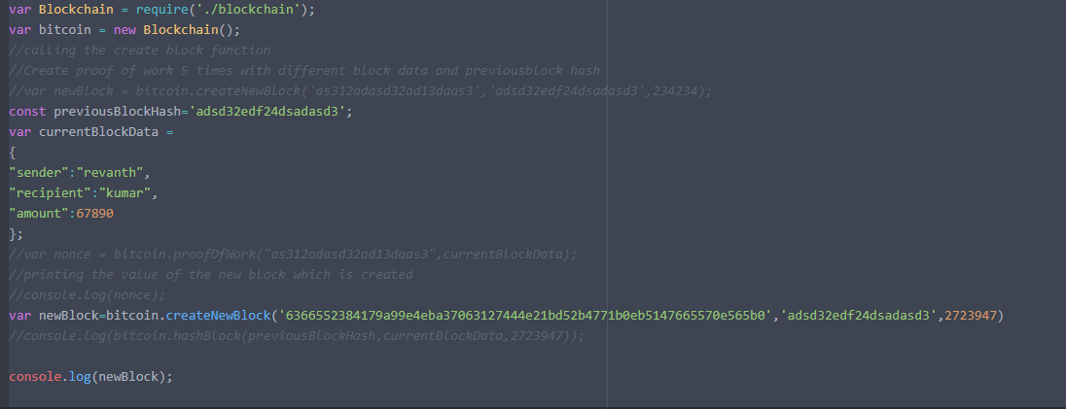

Created new block from the generated Hash

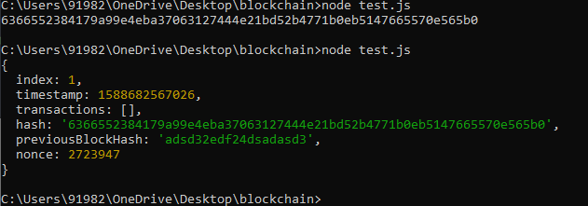

Created for 2nd block

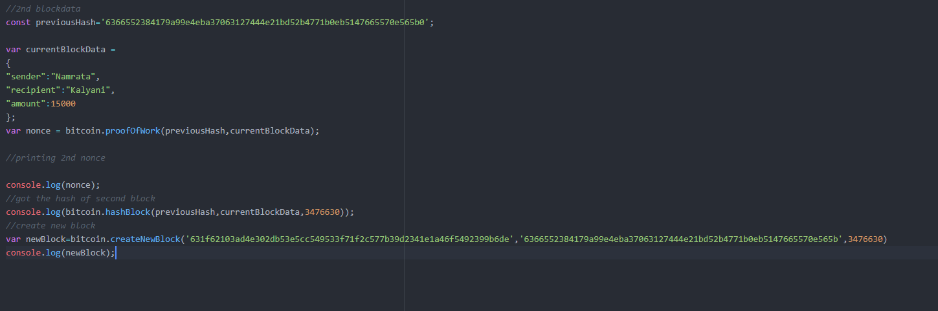

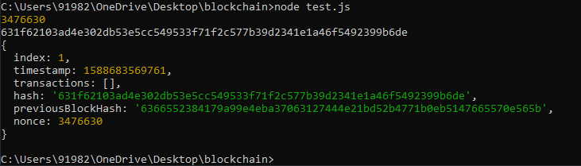

Create a new get function in your api.js, when you hit localhost:3000/sample  
on the browser it must show "this is my sample get call"

